**ŞUBAT AYI ÇALIŞMALARI**

1. [PROJE ORTAKLARIYLA TANIŞMAK İÇİN WEBİNAR](https://school-education.ec.europa.eu/en/etwinning/projects/small-steps-big-awareness/twinspace/pages/webinar-meet-project-partners)
2. [ÖĞRENCİ İŞ BİRLİĞİ ÜRÜNÜ-e-güvenlik alfabe kodlaması](https://school-education.ec.europa.eu/en/etwinning/projects/small-steps-big-awareness/twinspace/pages/student-collaboration-product-e-security-alphabet-coding)
3. [PROJE LOGOSU-POSTERİ-SLOGAN anket ve analiz sonuçları](https://school-education.ec.europa.eu/en/etwinning/projects/small-steps-big-awareness/twinspace/pages/project-logo-poster-slogan-survey-and-analysis-results)
4. [ÖĞRETMEN-ÖĞRENCİ-VELİ PROJESİ ÖN GÖRÜŞLERİ](https://school-education.ec.europa.eu/en/etwinning/projects/small-steps-big-awareness/twinspace/pages/teacher-student-parent-project-preliminary-opinions)

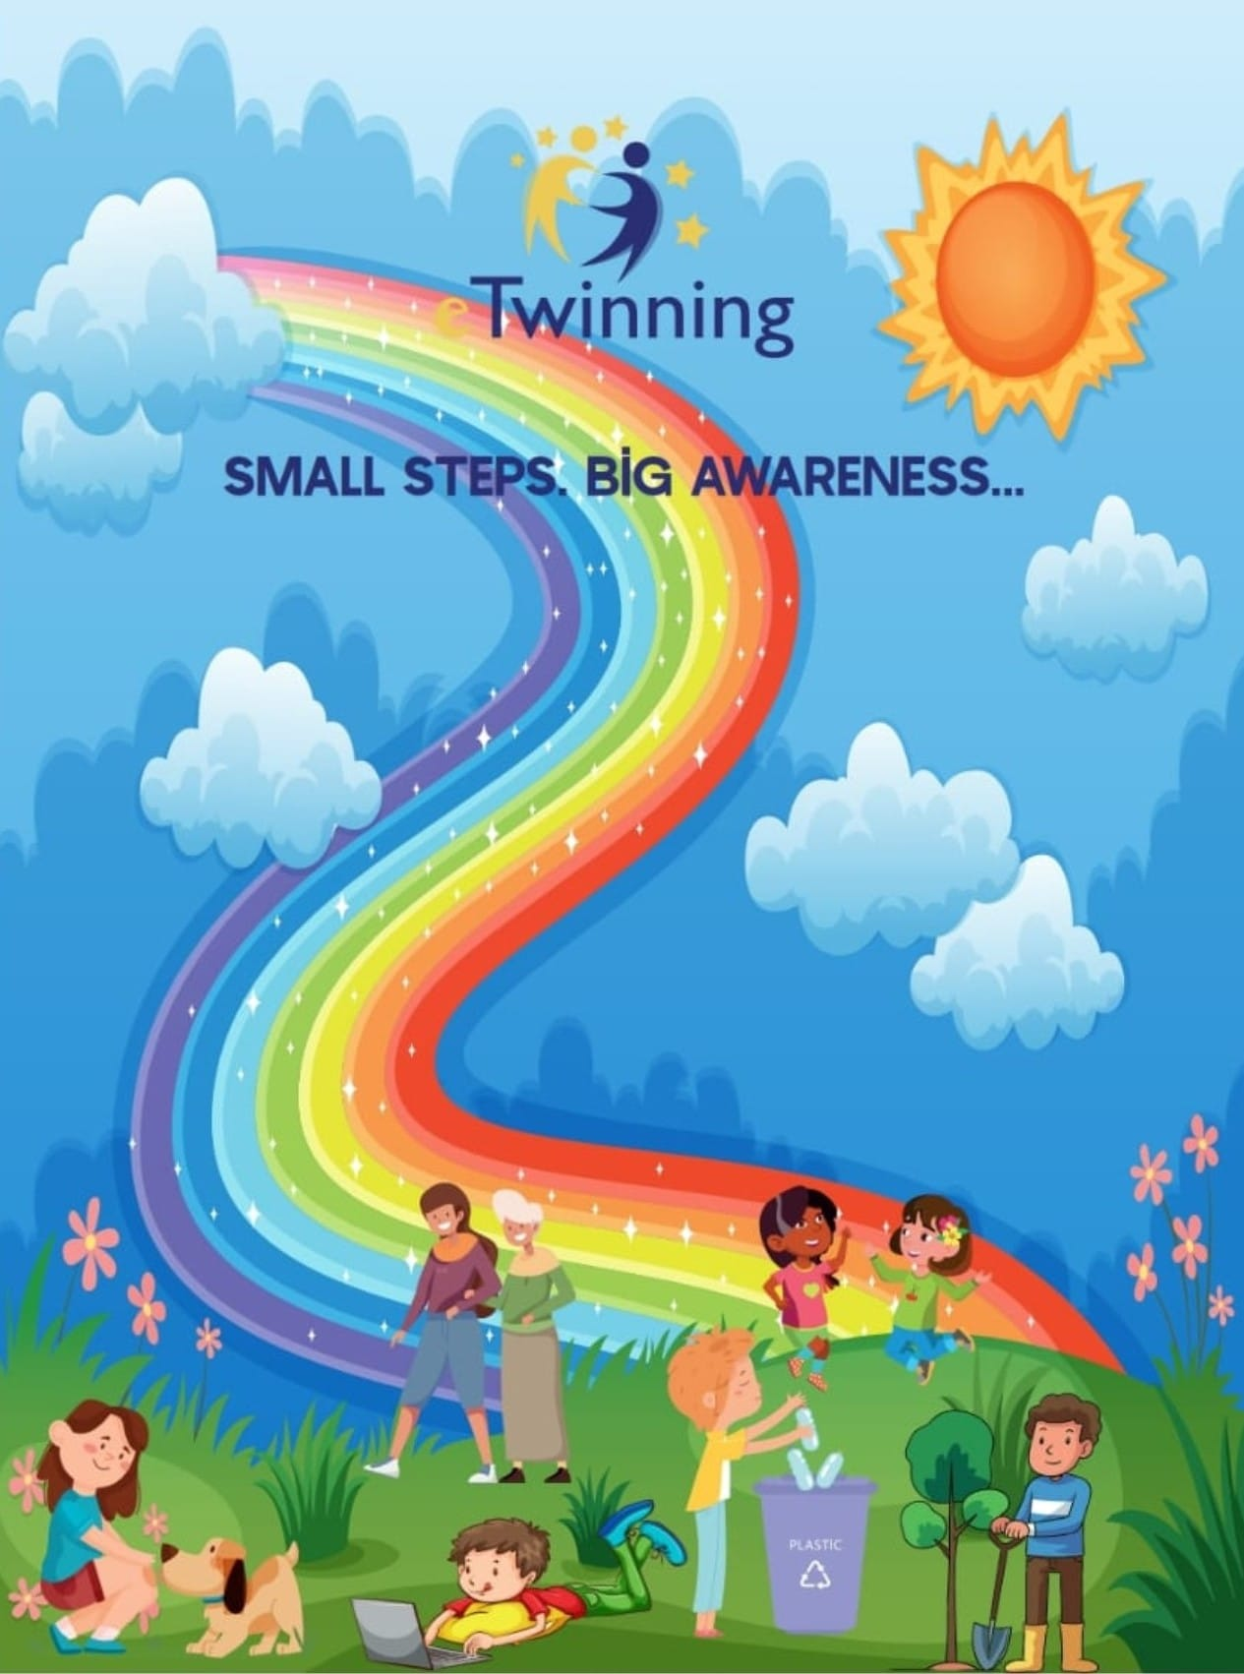

**Afiş tasarımımız**

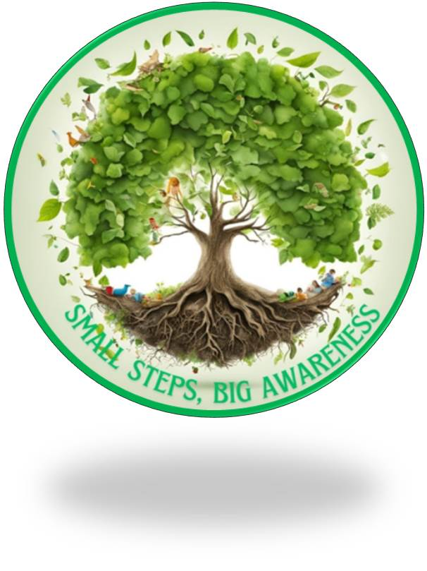

Logo tasarımımız

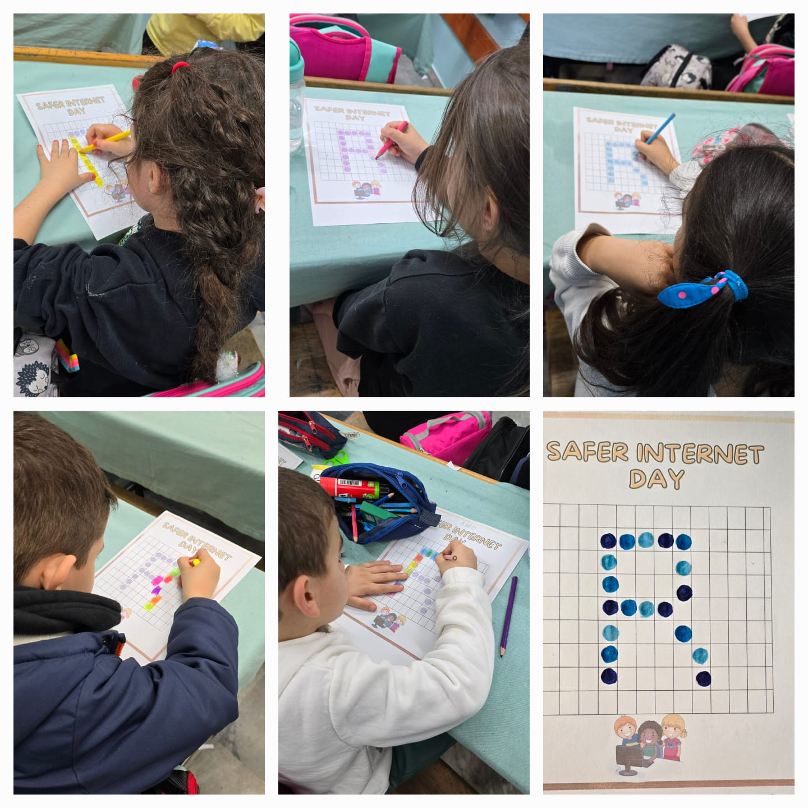

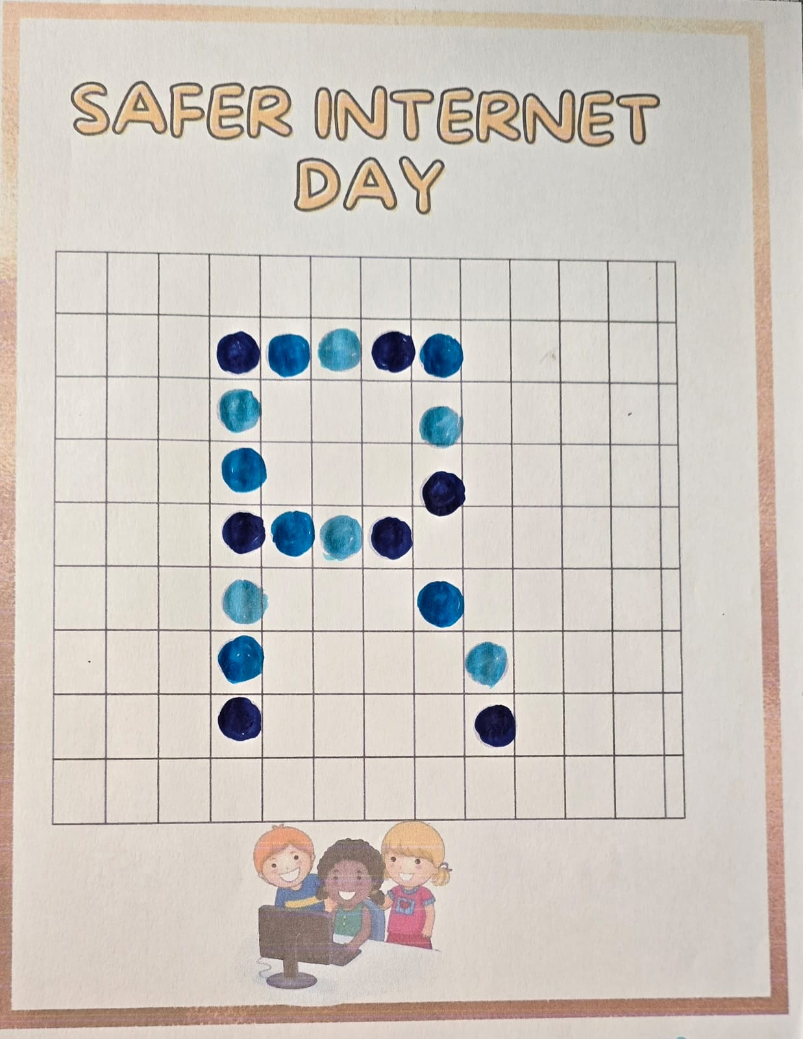

Güvenli internet Günü Alfabe kodlamamız

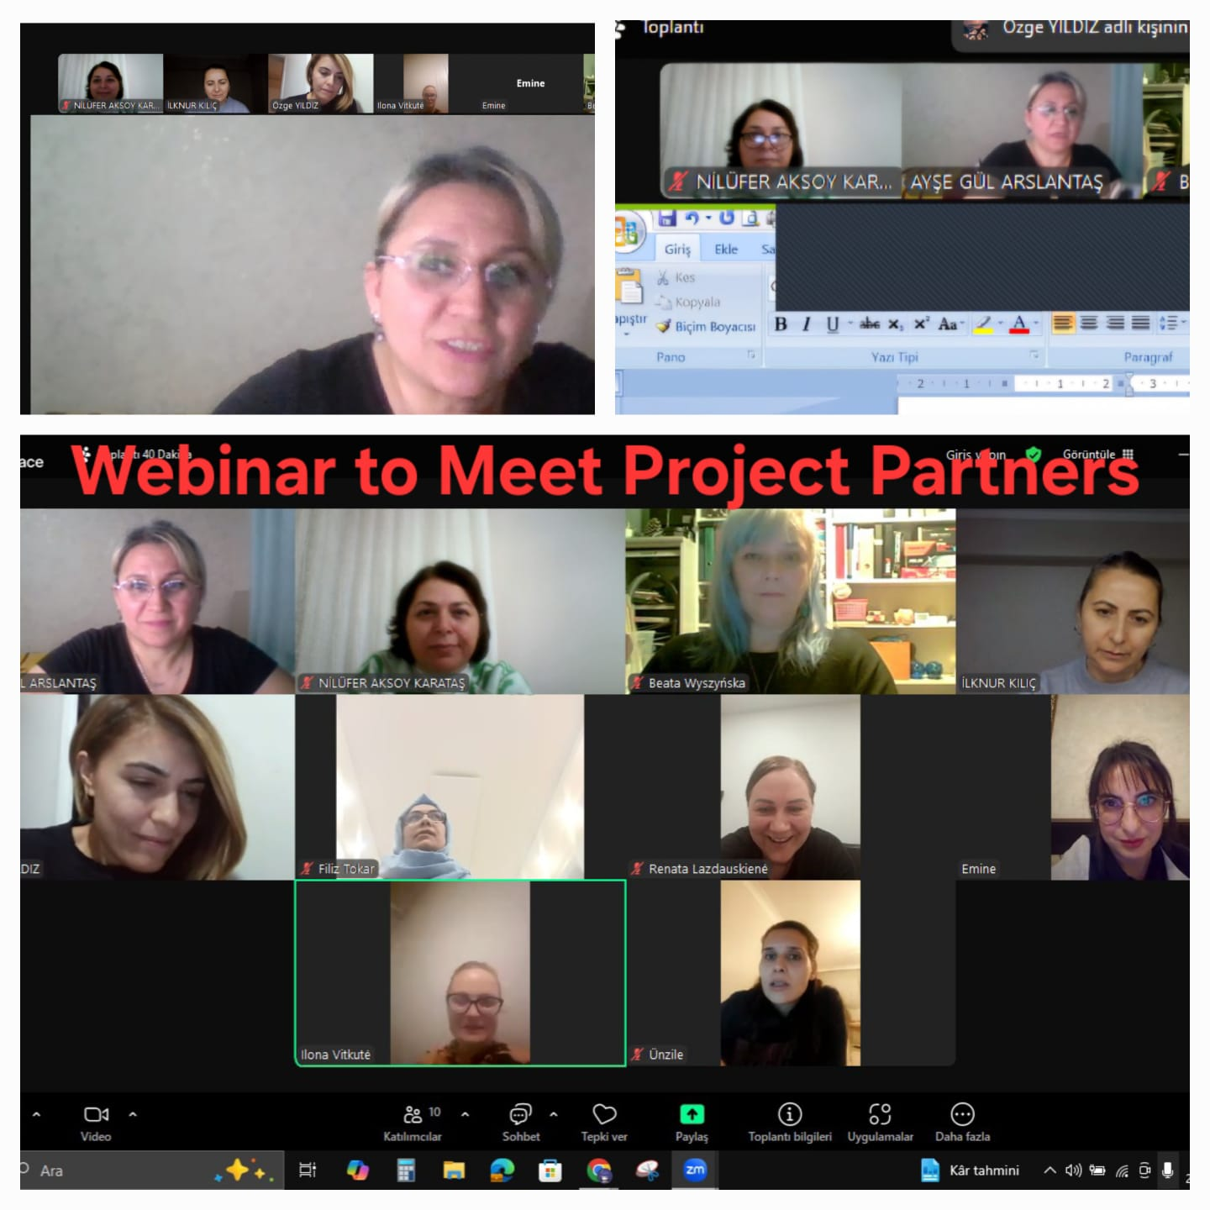

Ortaklarla Tanışma Webinarımız